**QUESTION 1**

**Q.1.1: Identifying the Need for the Project**

This project was needed because there are more and more safety problems in urban, township, and rural areas, where people struggle to handle emergencies and suspicious activities. Crime rates are going up, and communities don't have a simple way to report problems or get emergency help. The project solves this issue by giving residents a tool to report crimes anonymously, get quick safety updates, and work together to make their neighborhoods safer. The app will help people in the community respond better to safety threats by working as a team.

**Q.1.2: Technological Trend – Artificial Intelligence (AI)**

What is the technological trend?  
Artificial Intelligence (AI) is a technology that lets computers do tasks that usually need human intelligence, like learning, problem-solving, and recognizing patterns. It helps systems make decisions by analyzing large amounts of data.

How will the trend benefit the project in terms of timelines?  
AI will speed up the project by automating tasks like spotting crime patterns, handling reports, and sending real-time alerts. Instead of spending a lot of time on these tasks, the AI will do them automatically. This gives the development team more time to focus on other important parts of the app and helps meet the 10-month project deadline.

Potential risks of using AI:

1. Data Quality: If the data the AI uses isn’t accurate, the results might be wrong.
2. Cost: AI can be expensive to develop and might go over the budget of R1 500 000.
3. Ethical Concerns: Using AI to track and analyze personal data, like where users are, can raise privacy issues if not done properly.

How using this trend will benefit users:

* Real-Time Crime Detection: AI can quickly find suspicious activities by looking at data and alert users in real time to prevent crime.
* Personalized Safety Features: AI can give users tips and recommendations based on their behavior, like advice on how to secure their homes.
* Better Emergency Response: AI can look at past incidents and recommend faster emergency responses, helping people get help sooner.

**1.3 Project Charter**

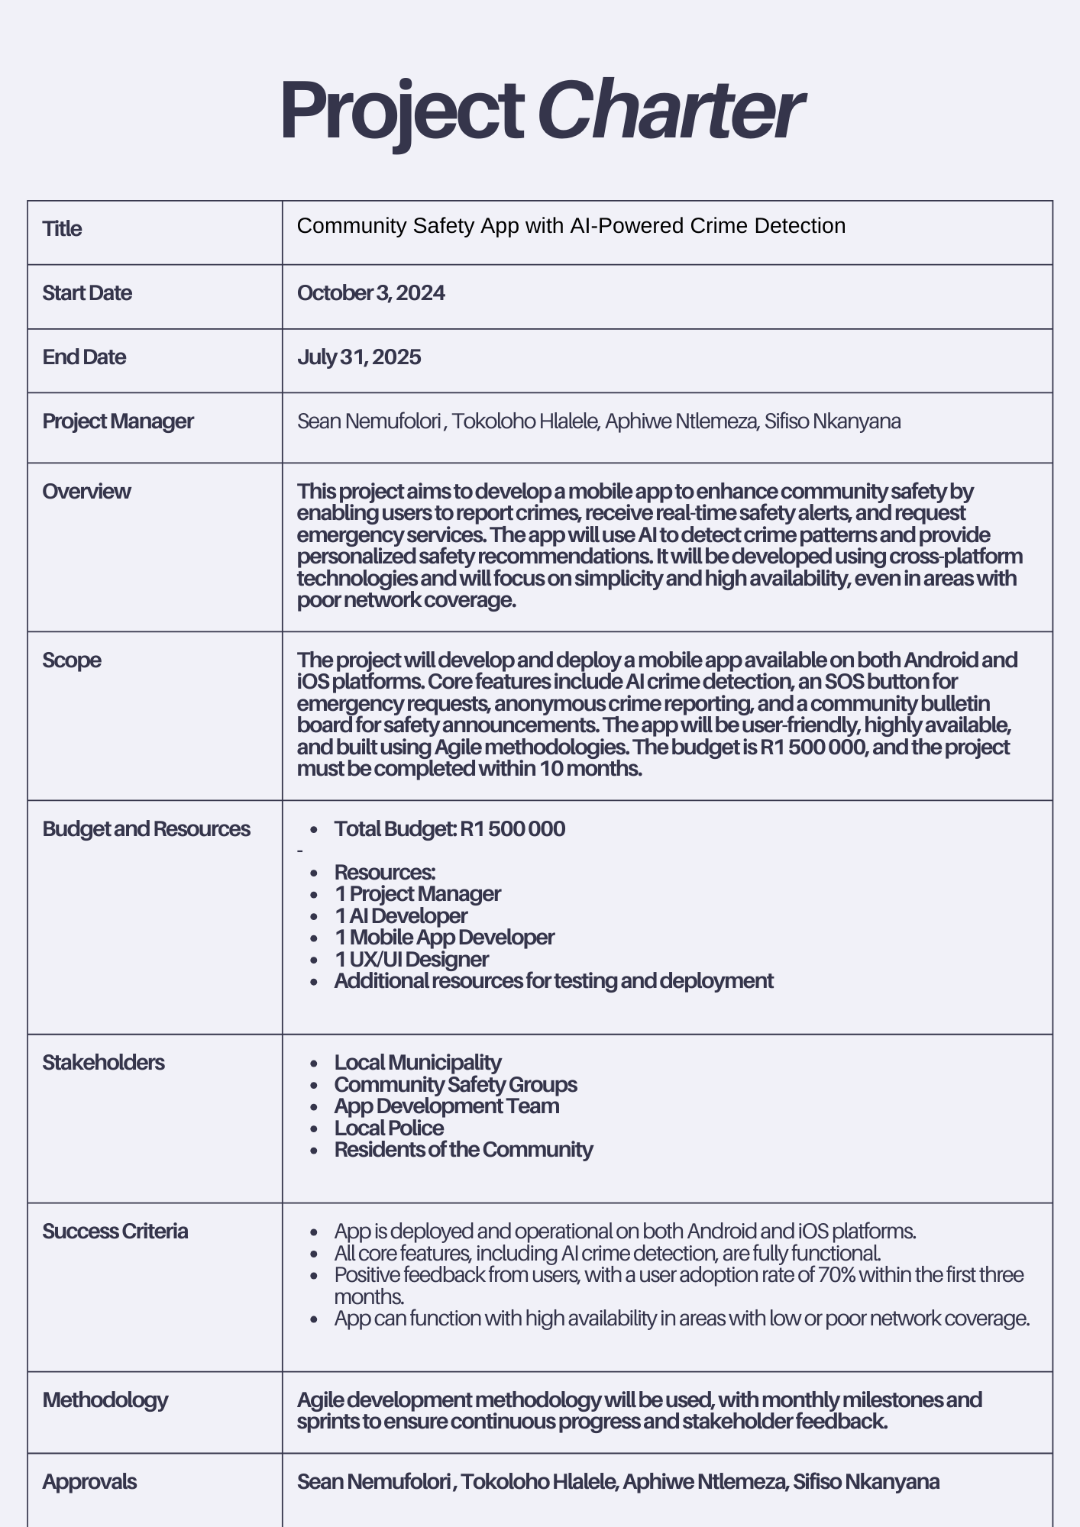

**WORK BREAKDOWN STRUCTURE TREE DIAGRAM TEMPLATE**

|  |  |  |  |
| --- | --- | --- | --- |
| **PROJECT TITLE** | Community Safety App with AI-Powered Crime Detection | **COMPANY NAME** | IPMA6212 Assignment 2 |
| **PROJECT MANAGER** | ST10332735,ST10262724,ST10352915,10352266 | **DATE** | 03 OCTOBER 2024 |

**Community Safety App with AI-Powered Crime Detection: R 1 500 000**

**Marketing and Launch: R200,000**

**App Design and Planning: R400,000**

**Testing and Deployment: R300,000**

**Development: R600,000**

**UI/UX Design R150,000**

**Quality Assurance Testing: R150,000**

**Deployment and Hosting: R150,000**

**Marketing Plan: R100,000**

**Launch Event Coordination : R100,000**

Create marketing materials

**Ayanda**

R50,000

Run a social media campaign

**Mthetho**

R30,000

Write a press release

**Nandi**

R20,000

Book the venue

**Naledi**

R30,000

Organize demos

**Thandi**

R40,000

Reach out to media

**Zoleka**

R30,000

Set up hosting

**Vhutshilo**

R60,000

Launch the app

**Lwandle**

R50,000

Monitor performance

**Sibusiso**

R40,000

Create test cases

**Rirhandzu**

R50,000

Conduct tests

**Thuli**

R60,000

Report and fix bugs

**Nkosinathi**

R40,000

Set up the database

**Ndivhuwo**

R100,000

Develop the API

**Zoleka**

R150,000

Configure the server

**Kgomotso**

R100,000

Code the user interface

**James**

R80,000

Add interaction features

**Nokuthula**

R100,000

Debug and fix issues

**Thabo**

R70,000

Create wireframes **Luyanda**

R50,000

Make mockups and prototypes

**Thandi**

R70,000

Gather user feedback and improve

**Siphesihle**

R30,000

Write requirements documentation

**Sipho**

R100,000

Design the technical structure

**Annelie**

R80,000

Schedule tasks

**Mpho**

R70,000

**Technical Specifications:R250,000**

**Front-end Development: R250,000**

**Back-end Development: R350,000**